Software Requirements Specification
For
PRODUCT REVIEW ANALYSIS PROJECT
Version 1.0
Prepared by KIGGUNDU ISMAIL SSALI, NUWASIIMA BRENDA, ABUBAKARI SIMBA, AYESIGA TONY NSUBUGA
GROUP 17
July 25, 2018
Table of Contents
Table of Contents ii
Revision History ii
1. Introduction 1
1.1 Purpose 1
1.2 Document Conventions 1
1.3 Intended Audience and Reading Suggestions 1
1.4 Product Scope 2
1.5 References 3
2. Overall Description 3
2.1 Product Perspective 3
2.2 Product Functions 4
2.3 User Classes and Characteristics 4
2.4 Operating Environment 4
2.5 Design and Implementation Constraints 4
2.6 Assumptions and Dependencies 5
3. External Interface Requirements 5
3.1 User Interfaces 5
3.2 Hardware Interfaces 7
3.3 Software Interfaces 7
3.4 Communications Interfaces 8
4. System Features 8
4.1 Grammar Check 8
4.2 Ratings 8
4.3 Frequency of Words 9
5. Other Nonfunctional Requirements 9
5.1 Performance Requirements 9
5.2 Safety Requirements 9
5.3 Security Requirements 9
5.4 Software Quality Attributes 10
5.5 Business Rules 10

Revision History
Name | Date | Reason For Changes | Version

Table of Figures
Figure 1. Analysis process Illustrations 3
Figure 2. Home page 6
Figure 3. Rating Page 6
Figure 4. Word counter page Illustration 7

Introduction

Purpose
The purpose of the document is to specify the overall system requirements that will govern the development and implementation of the Product Review Analysis system (PRAS). PRAS will analyze customer reviews versus product.
In short, the purpose of this document is to provide a detailed overview of our software product, its parameters and goals. This document describes the project's target audience and its user interface, hardware and software requirements. It defines how our client, team and audience see the product and its functionality. Nonetheless, it helps any designer and developer to assist in software delivery lifecycle (SDLC) processes.

Document Conventions
This document uses the following conventions:
Document acronyms
- PRAS - Product Review Analysis System
Document standards
- Times New Roman
- Size 12 body
- Line spacing 1.5
- IEEE REFERENCING FORMAT

Intended Audience and Reading Suggestions
The intended audiences for this specification include;
Mostly this document is intended for the development team of PRAS which include Programmers, Architects, System testers, System Analysts etc.
Other groups of people that might need to read the document include;
- Customer representatives
- User Support Agents.
- Marketing staff

Product Scope
Product Review Analysis system is a web based system that will analyse customer reviews from over 1000 products provided by different online markets. PRAS will be used to assess how writing quality impacts product reviews. Both positive and negative online product reviews, this will be done by analyzing reviews for grammatical errors, frequency of particular words, and product ratings.

Furthermore, PRAS needs an internet connection to fetch and display results. Users will be required to upload a csv file which contains the reviews to be analysed. PRAS will be accessed via smartphones and Computers.

PRAS comes with a number of Benefits which include;
Customer benefits.
- Customer compensation in case of complaints e.g. through product replacement.
Producer benefits
- It enables producers to improve on the quality of products basing on customer reviews.
- Widening the market base of products due to increase in rating.
- It improves customer to producer relationships through interaction.
- Enables producers to easily identify the product to put in check through review analysis.

References
[1] IEEE Software Engineering Standards Committee, “IEEE Std 830-1998, IEEE Recommended Practice for Software Requirements Specifications”, October 20, 1998.
[2] Davis M A, “Just Enough Requirements Management: Where Software Development Meets Marketing”, New York, Dorset House Publishing, 2005.
[3] Karlsson J, “A Cost-Value Approach for Prioritizing Requirements”, Norges Teknisk-Naturvitenskapelige Uni. 1997

Overall Description

Product Perspective
PRAS will be a self-contained web-based system that can only be accessed via the internet. Customers, Product Manufacturers, Online Market employees, Retails traders and all users will be able access the system from anywhere via their smartphones or their computers. The data to be used by PRAS must be uploaded by the users of the system in form of a csv file.
Illustration showing Analysis process
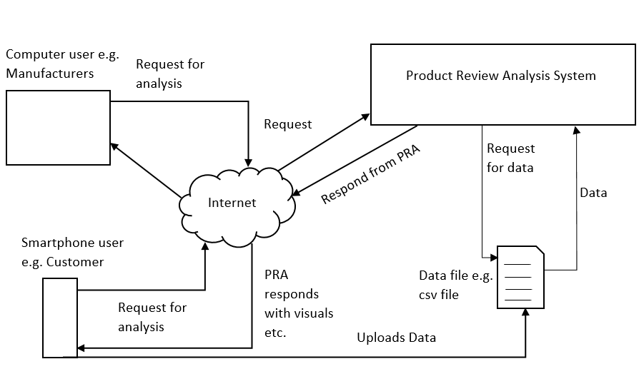
Figure 1. Analysis process Illustrations

Product Functions
Since PRAS will be a web portal that will be accessed via different devices such as smartphones and Personal computers etc., therefore it comes with many functionalities as listed below;
PRAS users will be able to visualize how different products information affects user review.
Product Manufacturers will be able to know the performance of their different products on the market i.e. whether their products are on high demand or they are declining, whether customers are satisfied or not and more.

User Classes and Characteristics
Users of PRAS must be computer Literate. Users must have a smartphone or computer with an internet connection in order to use the system.
Users of PRAS with smartphones will not be able to access some of the functionalities since some functions of PRAS require a lot processing power that a smartphone does not possess.
Most of the functionalities of PRAS will be available for computers users.

Operating Environment
PRAS will be accessed on computers running Windows, Linux and Mac operating systems since it is a web based system.

Design and Implementation Constraints
The Internet connection is also a constraint for PRAS. Since PRAS is a web based system, users will be required to upload a csv file via the internet. It is crucial that there must an Internet connection for PRAS to function.
PRAS will be constrained by the number of users. Since PRAS is shared between smartphone users and computer users, it may be forced to queue incoming requests and therefore increase the time it takes to fetch data.

Assumptions and Dependencies
One assumption about PRAS is that it will be used on smartphones that have enough performance. If the phone does not have enough hardware resources available for the application, for example the users might have allocated them with other applications, there may be scenarios where the application does not work as intended or even at all.
PRAS entirely depends on an internet connection for its operation.

External Interface Requirements

User Interfaces
In figure 1 below, illustrates how the Home page of PRAS shall look like and gives a brief description of how the web based system would work. The home page gives a brief description of the features or tools that PRAS has.
Figure 2 illustrates how the users of the PRAS would be able to determine the frequency of a particular word in a product review using the word counter feature. This would help users differentiate from positive and negative online product reviews.

Home Page
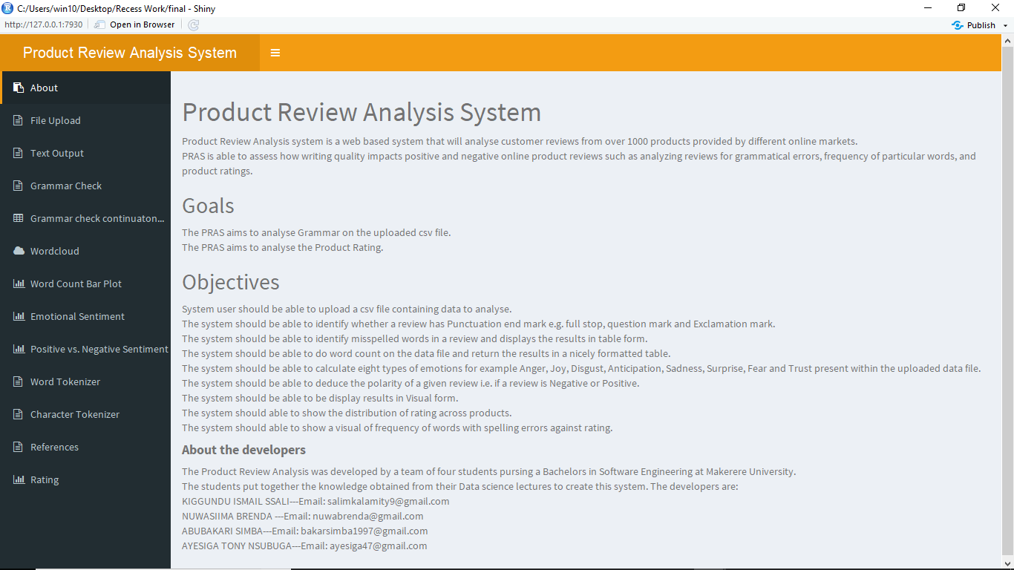
Figure 2. Home page

Rating page

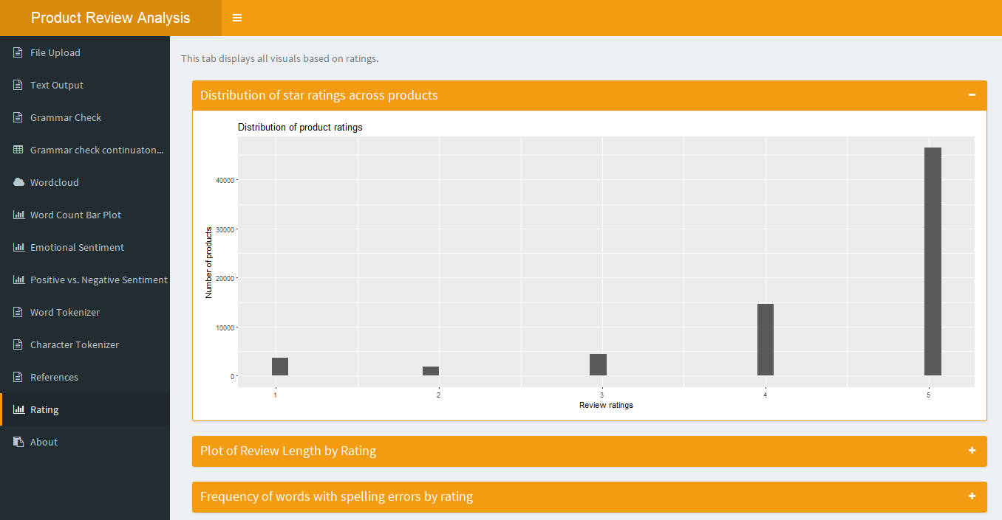
Figure 3. Rating Page

Word counter page
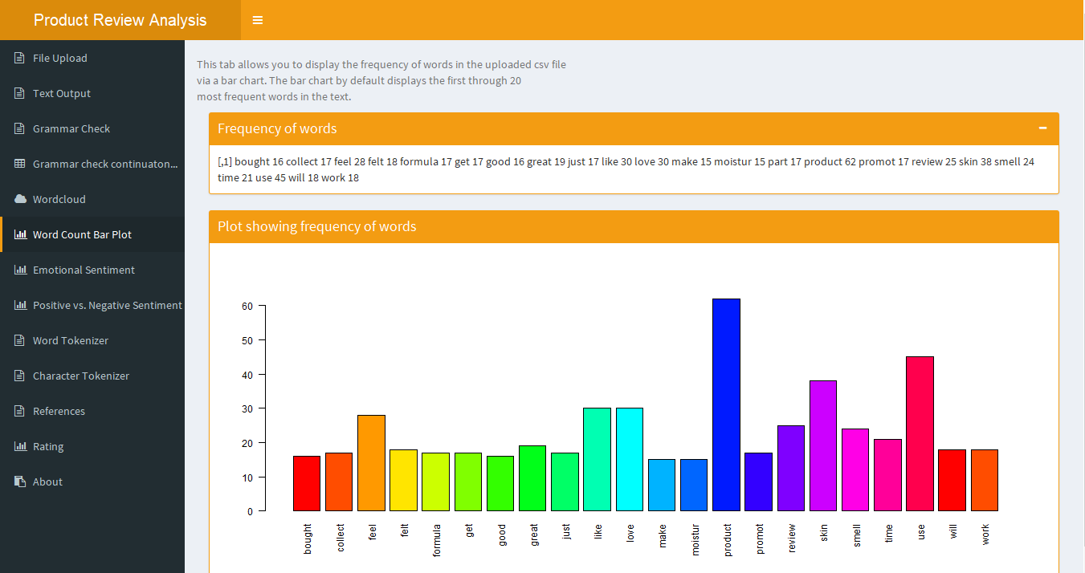
Figure 4. Word counter page Illustration

Hardware Interfaces
The user will the access the software or the PRAS interface using a computers and smartphones. The input data will be received using keyboard, mouse to send search requests. The system responds to these requests by displaying results or visual graphics on the monitor.

Software Interfaces
Software Used | Description
Operating system | The development team chose Windows OS because of its user friendly.
Integrated Development Environment e.g. RStudio | To implement the system, we chose the RStudio.

Communications Interfaces
PRAS will support all types of browsers that support HTTP protocol.

System Features

Grammar Check
4.1.1 Description and Priority
PRAS analyses grammar in product reviews i.e. spelling errors, punctuations, statement length and character length.
4.1.2 Stimulus/Response Sequences
PRAS searches for grammatical errors immediately upon single click and display statistics.
4.1.3 Functional Requirement
REQ-1: PRAS should be able to identify grammatical errors in online product reviews.

Ratings

Description and Priority
- Displays the distribution of ratings across products.
- It also shows how the length of reviews affects the product ratings.
- How spelling errors in review are related to the ratings.

Stimulus/Response Sequences
Displays ratings graphs.

Functional Requirement
REQ-1: PRAS should be able to display products ratings with respect to review features.

Frequency of Words

Description and Priority
Displays the frequency of certain words which helps users to determine whether it is a positive or negative review.

Stimulus/Response Sequences
- Immediately returns frequency of a particular word in a product review upon its search.

Functional Requirement
REQ-1: PRAS should be able to return the number of times a particular word has appeared in a product review.

Other Nonfunctional Requirements

Performance Requirements
PRAS will be based on the web and has to be run on a web server. PRAS shall take initial load time depending on internet connection strength which also depends on the media from which PRAS is run.
The performance shall depend upon hardware components of the client/customer.

Safety Requirements
In case of any catastrophic damage such as server crash, PRAS should be able to use a recovery method to restore previous session for the active users and reconstruct the previous activities.

Security Requirements
PRAS should be able to access a secure data from a secure source. If the data file is corrupted, then PRAS will give a wrong analysis.
The file under analysis is uploaded on spot, hence the csv file information is not corrupted in case of any system malfunction.

Software Quality Attributes
AVAILABILITY: PRAS should be up and running 24 hours a day and seven days a week.
RELIABLE: PRAS should be able to give a correct analysis from the product reviews.
MAINTAINABILITY: PRAS should be easy to extend. The code should be written in a way that it favors implementation of new functions.
PORTABILITY: PRAS should be portable to run on any Operating system.
USABILITY: PRAS should be able to satisfy a maximum number of customers’ and producer’s needs.

Business Rules
Once the development of PRAS is done, the development team will continue to maintain it and in case of any catastrophic damage to the system, the development team should be called to handle the issue.

MAKEREREUNIVERSITY
COLLEGE OF COMPUTING AND INFORMATION SCIENCES
DEPARTMENT OF NETWORKS
BACHELOR OF SCIENCE IN SOFTWARE ENGINEERING (YEAR 2) RECESS TERM 2 (BSE 2301)
SYTEM REQUIREMENT SPECIFICATIONS

GROUP 17

PROJECT LEADER: KIGGUNDU ISMAIL SSALI
GROUP MEMBERS
NAME | REG. NO | STUDENT NO. | SIGN
NUWASIIMA BRENDA | 16/U/2093 | 216002098
ABUBAKARI SIMBA | 16/U/2618/PS | 216010199
KIGGUNDU ISMAIL SSALI | 16/U/5959/PS | 216004419
AYESIGA TONY NSUBUGA | 16/U/4043/PS | 216012265

ADVISOR: NOAH KANGE
SUBMITTED IN PARTIAL FULFILLMENT OF THE REQUIREMENTS FOR THE SOFTWARE ENGINEERING RECESS PROJECT BSE 2301
27ST​JUNE, 2018

